Integration Studio is designed to create a rigid and transparent system for Integrations.
To make a hassle free and easy to understand flow for Integrations is the goal of Integration Studio

- Configurability
  - Easy to extend it new verticals
  - With fully configurable parameters for Integrations. Studio lets user be more flexible with Integrations
- Transparency ( Productivity of Developer, Blockers, Delays, Burndowns)
  - Productivity
    - Users (Dev) can see progress, escalate issues, review and test the mappings on the platform itself
  - Blockers
    - Blockers are fully visible in the studio. Every wait-pause, delay is taken into measure.
    - It allows users to escalate and resolve the blocker asap.
  - Reports
    - In the studio, we have the following reports.
      - Integration-wise
      - Mappings-wise
      - Delay wise
      - Business function wise
      - Developer wise
      - Day wise
- Ease of Mapping
  - Natural Playground for Developers. He can do mapping by looking at actual payload in JSON or XML format
- Communication Framework
  - Single Source of truth for all communications

Integration Platform Flow:

Main Stages:-

- Plan
- Hypothesis
- Insurer profiling
  - Insurer Contacts
  - Readiness & Scope
  - Insurer masters
  - API Details
  - Other Info
- Development
  - Planning
  - Setting
  - Mapping
  - Dev Testing
- UAT
  - UAT Performed By
  - Test Cases
  - Issues
  - Approval
- Go Live
  - Credentials
  - Mapping Approval
  - Sanity
  - Approval

Create products:

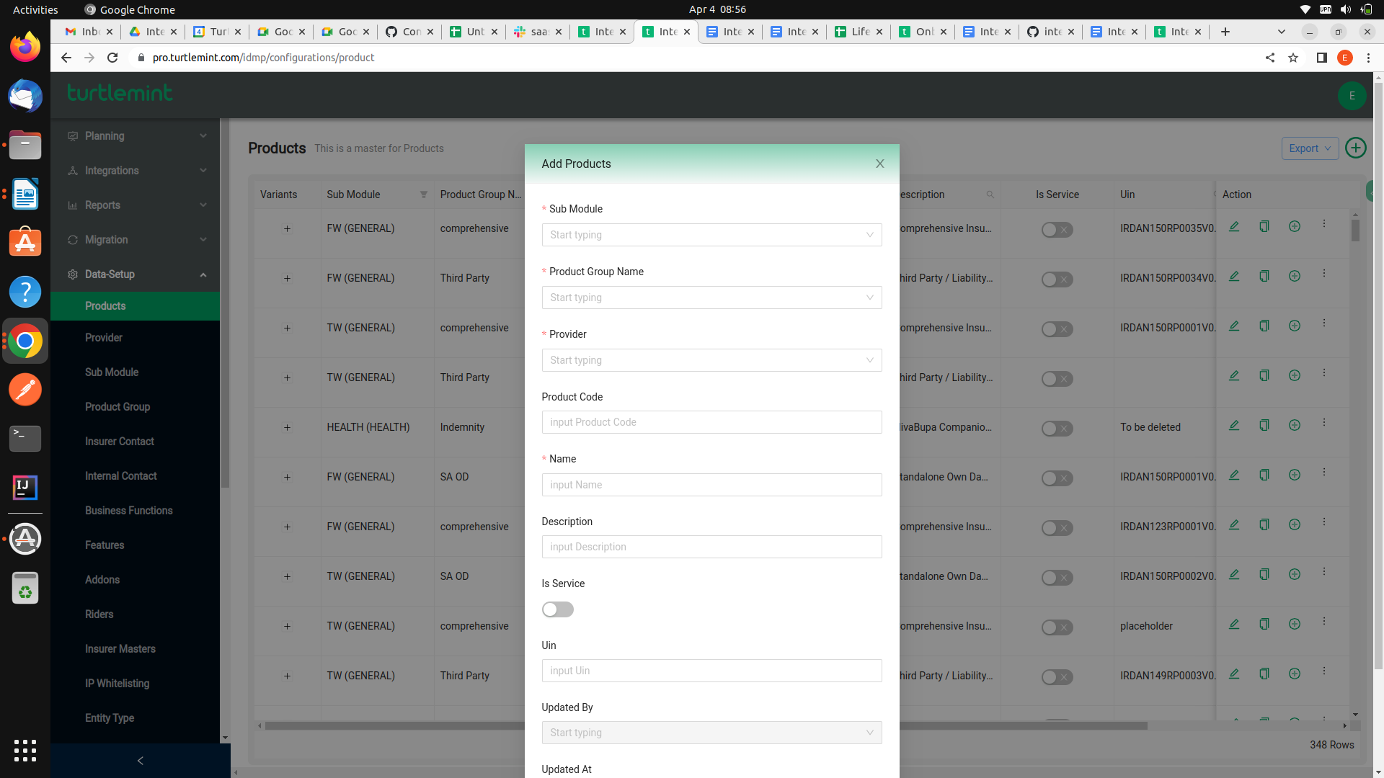
Create plan:

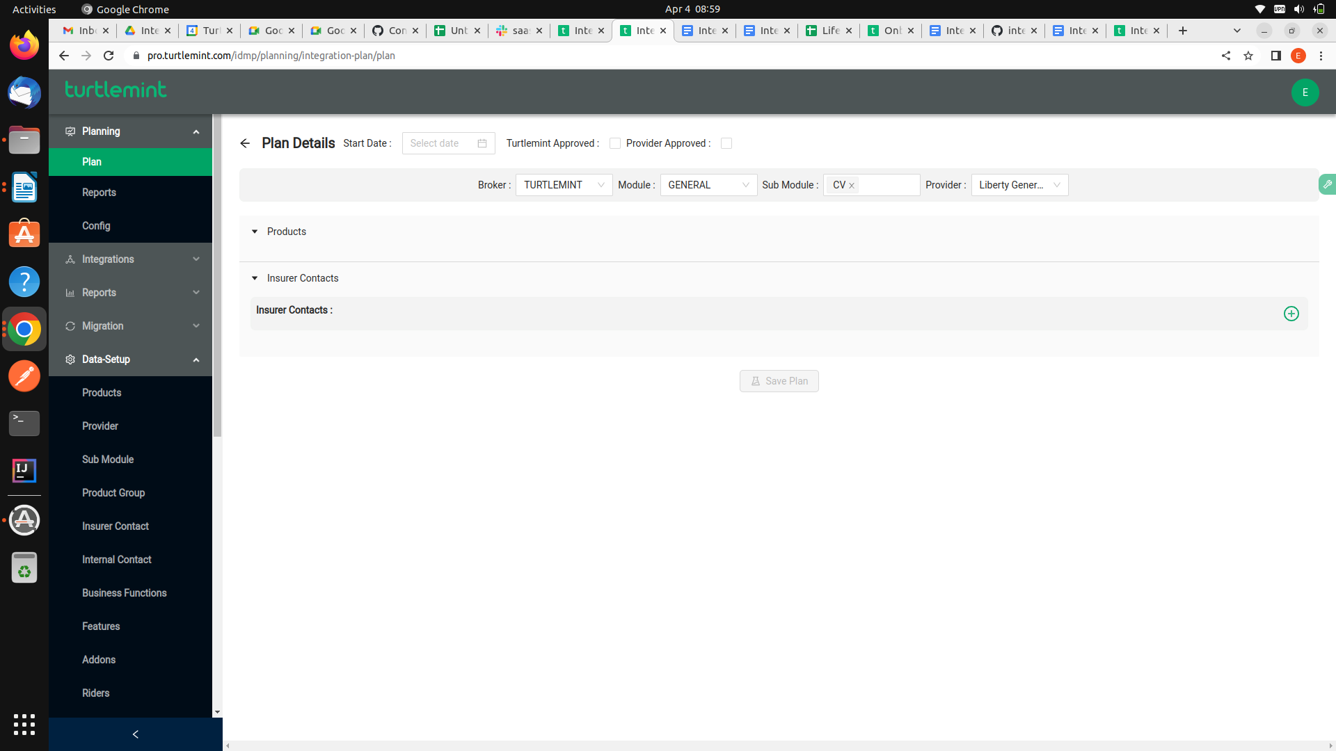

Plan details:
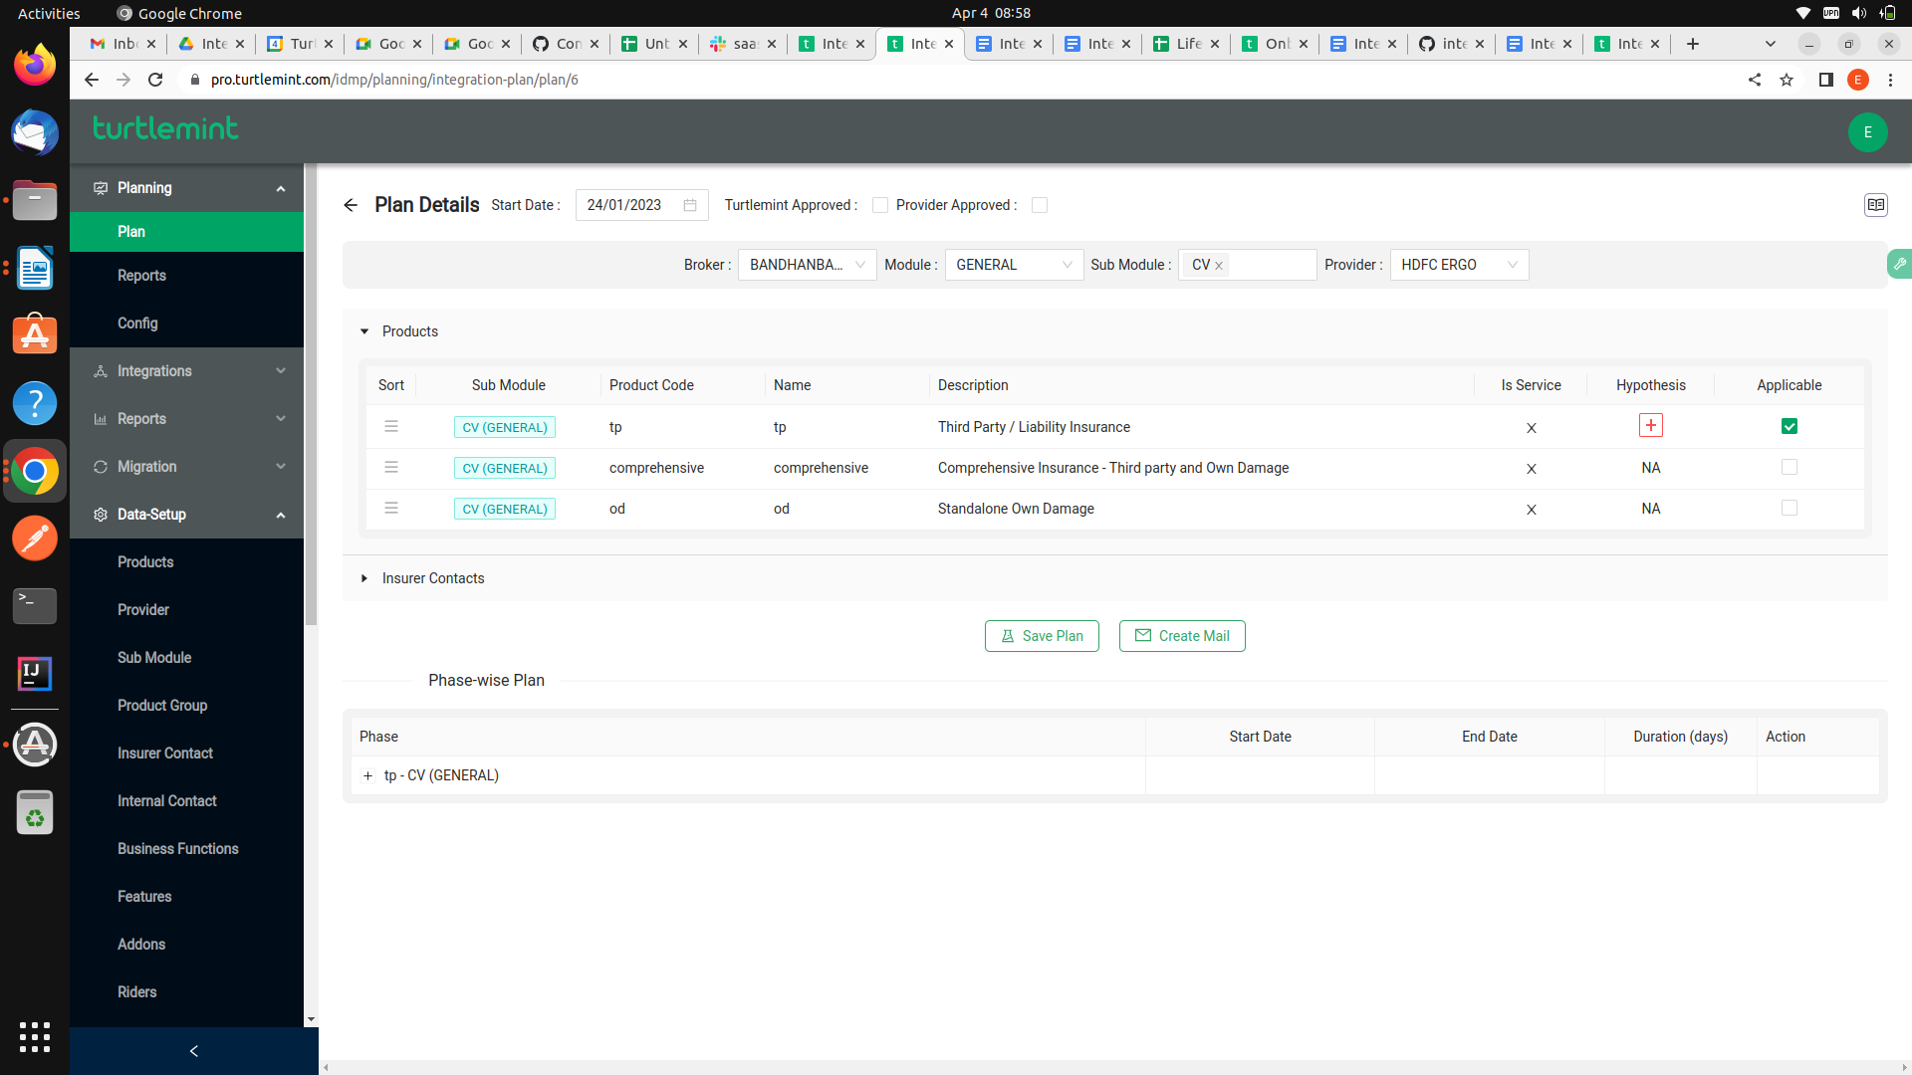

New Integration:
